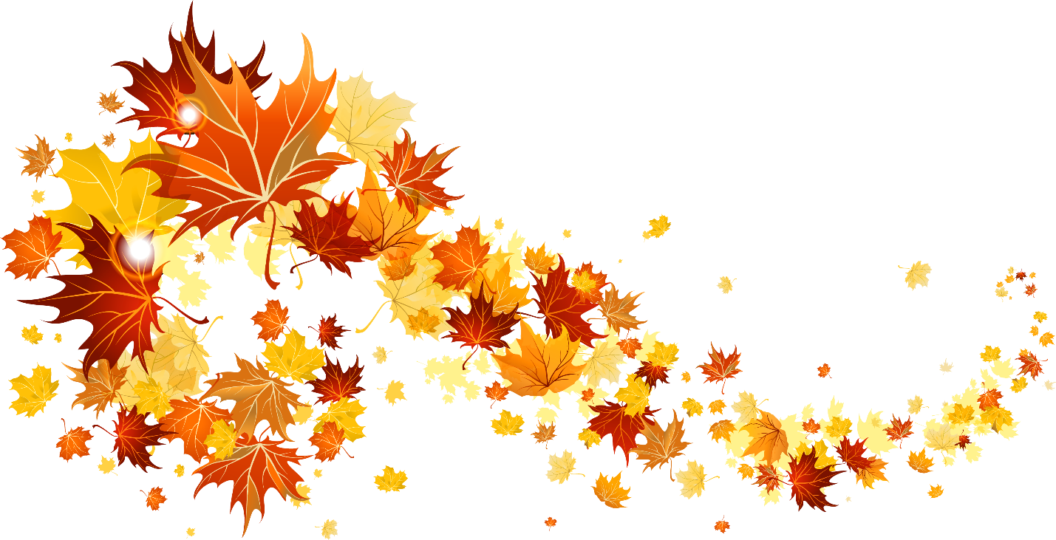

**FALL IS HERE AND Recruiting is too!!!**

**Mark your calendar and plan to attend these upcoming events :**

**September 7th and 8th -- Chattanooga Area College Fair**

**In the Gym from 9:00 am until 1:00 pm**

**(Division Tables reserved)**

**October 21 -- Chattanooga State October Fest 10:00-1:00**

**November 8 – Annual Counselors’ luncheon 11:00-1:00**

**Imp: Your RSVP is needed for each event. Please email** [**shirley.moore@chattanoogastate.edu**](mailto:shirley.moore@chattanoogastate.edu) **or call 697-2689.**